Name:_______________________________________

Plant Cell
Cell Membrane (orange)  Nucleus (yellow)  Mitochondria (red)  Vacuole (lt. Blue)  DNA (lt brown) | Cell Wall (dark green)  Nucleolus (brown)  Chloroplasts (light green) | Ribosome (purple)  Cytoplasm (white)  Golgi Apparatus (dk blue)
 | Endoplasmic Reticulum (pink)
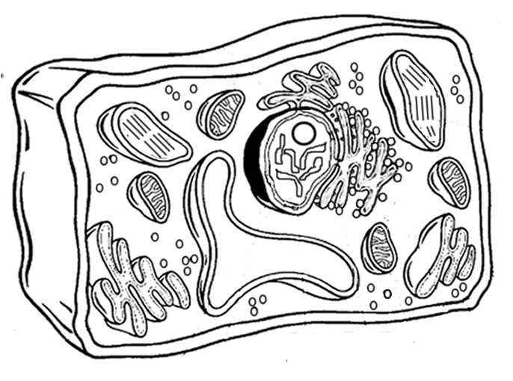
Plant Cell Coloring Key

